Sql: exist

Used in sub query/inner/nested

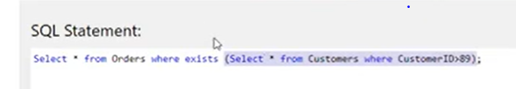

If sub curry gets any records

Exists(subquery) becomes true

Then only select * from orders execute and gives results of only that query

Sub query is used only to check the condition true or false not for fetching records

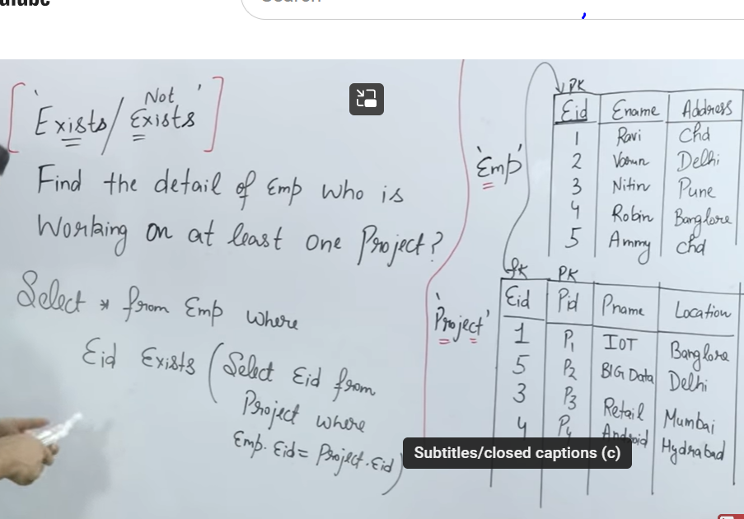

Top to down approach

First it select one row in outer query and check condition of sub query , then fetch the record of outer query

Exist and not exist – return true and false

But where as “in and Not in) inner query execute only once

Where as exist where inner query execute every time or row by row to check condition

Take one row from outer query table check if the record is there in table mention in inner query if exists-true- gives that record \

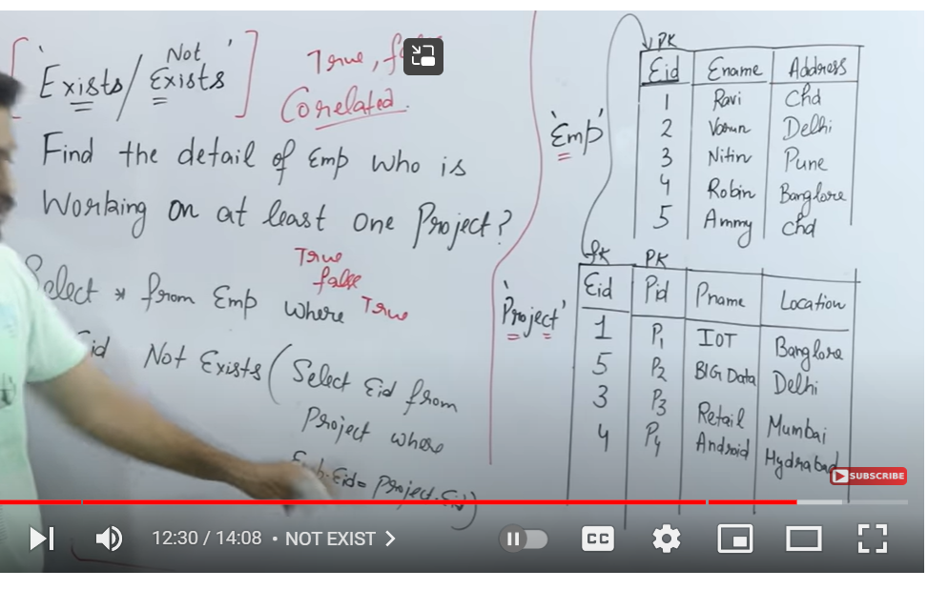

Subqueries:

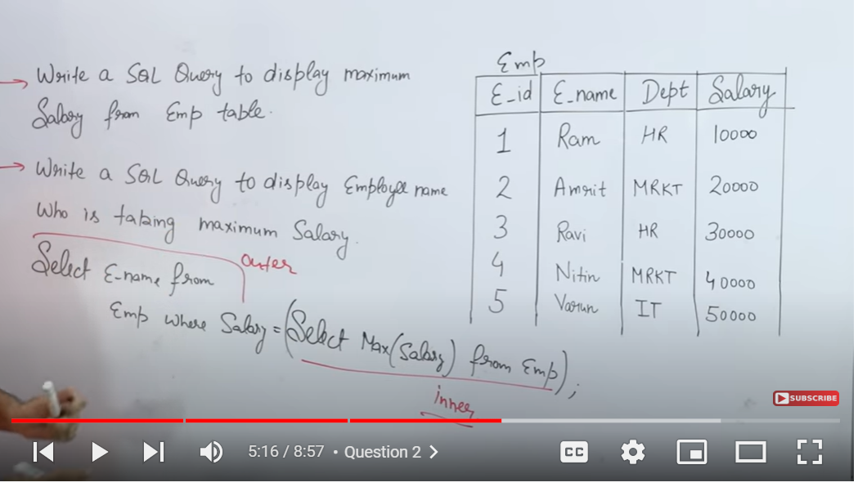

**First inner query gets executed then outer query**

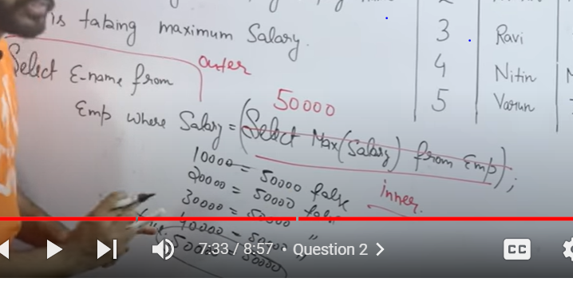

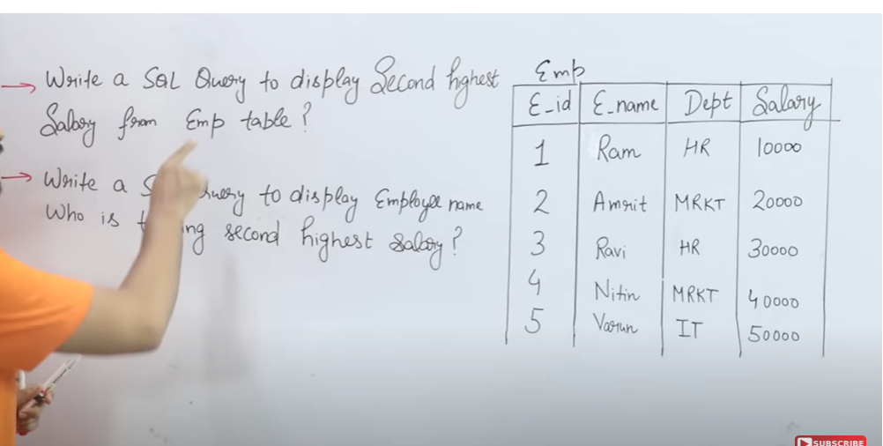

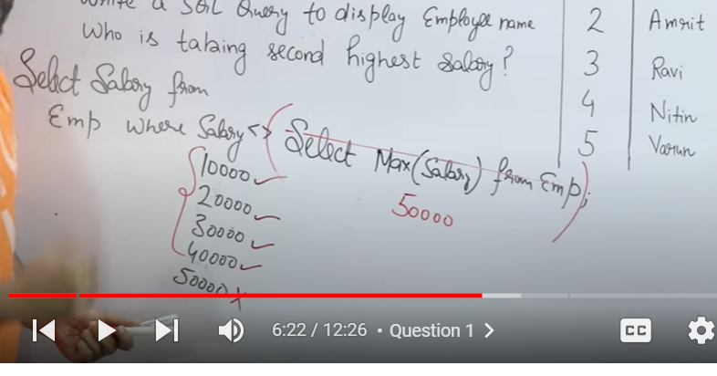 **first we need to exclude highest salary**

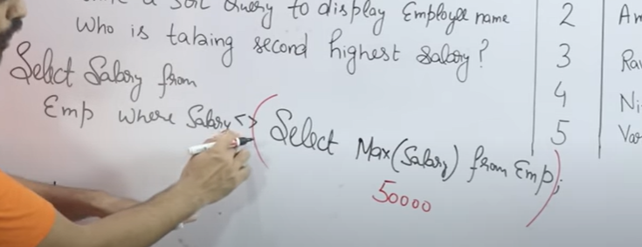

**Then we need to find highest from remaining records**

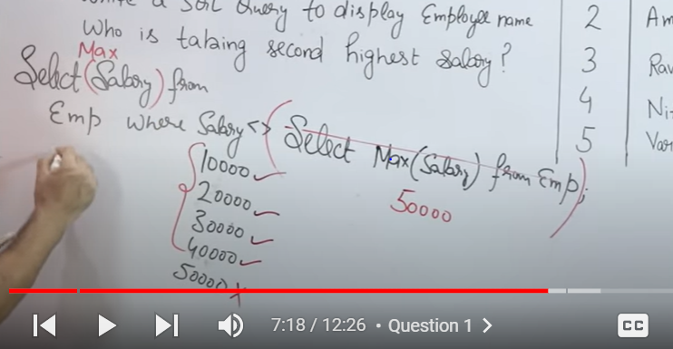

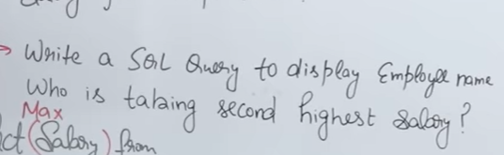

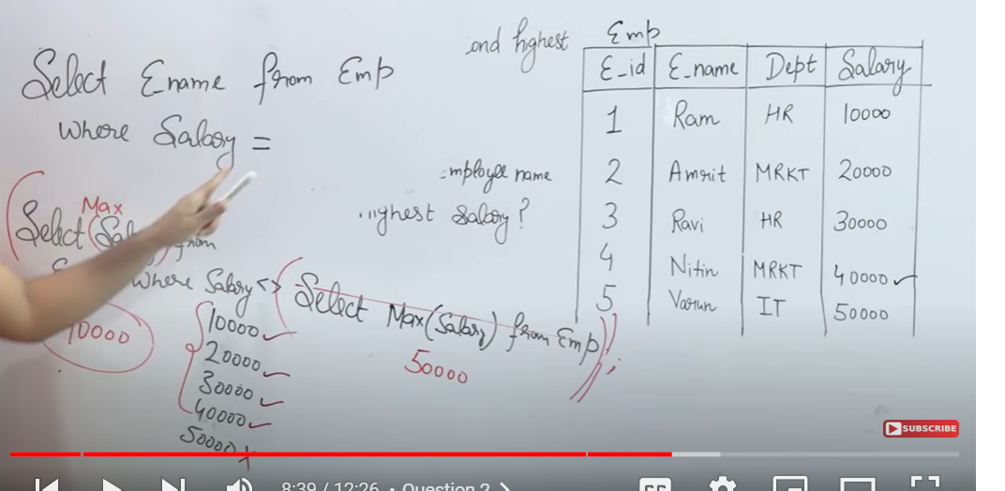

**We can use both IN and =**

**=”to compare one value”**

**IN – to compare multiple values**



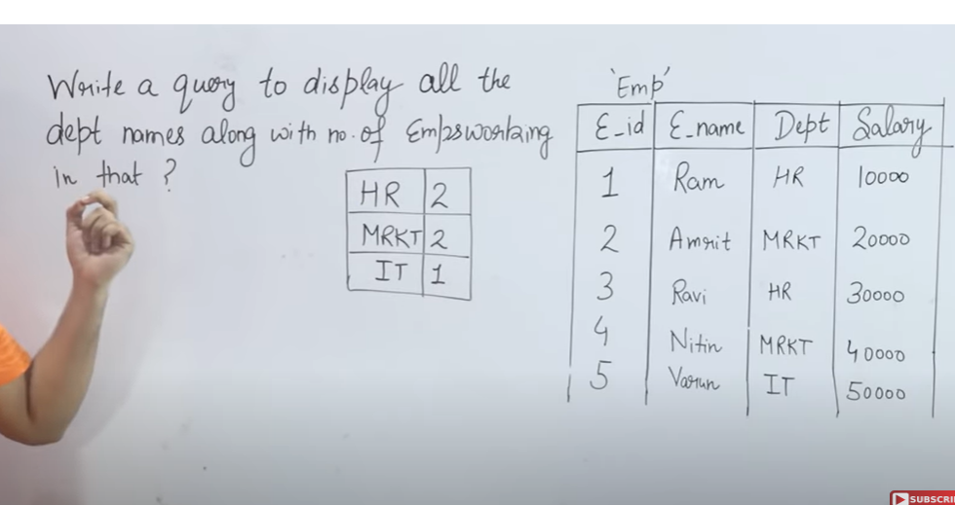

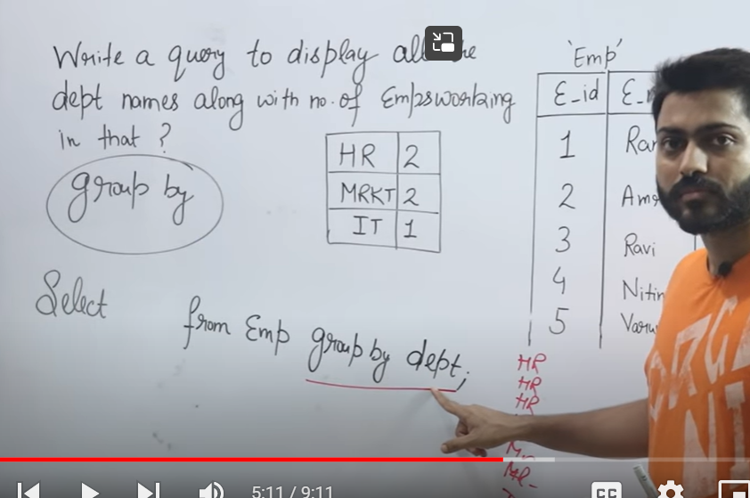

**What to write select list in group by**

**1.On which column we are doing groupby**

**2. 2nd – aggregate function(which we are calculating by groupby)**



**Having**

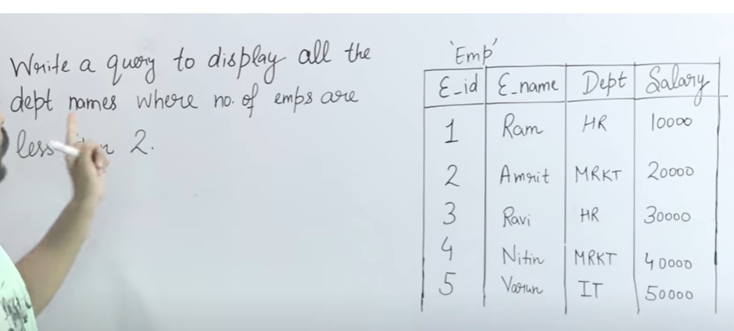

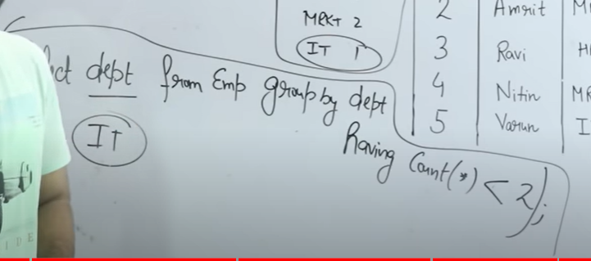

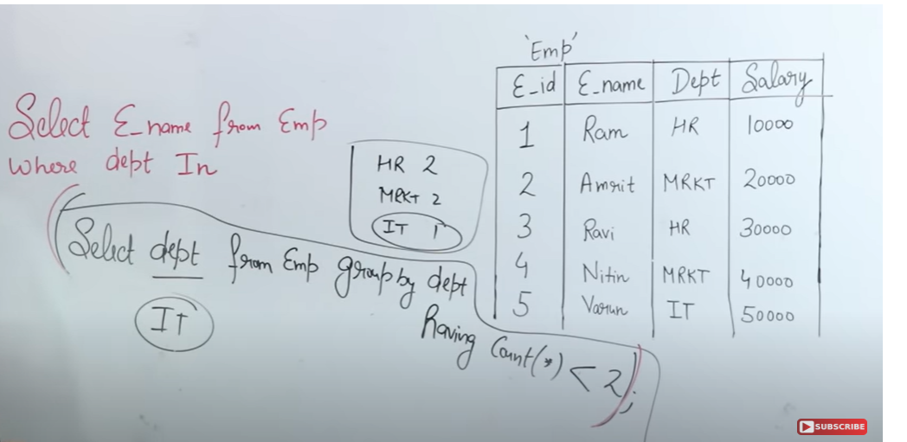 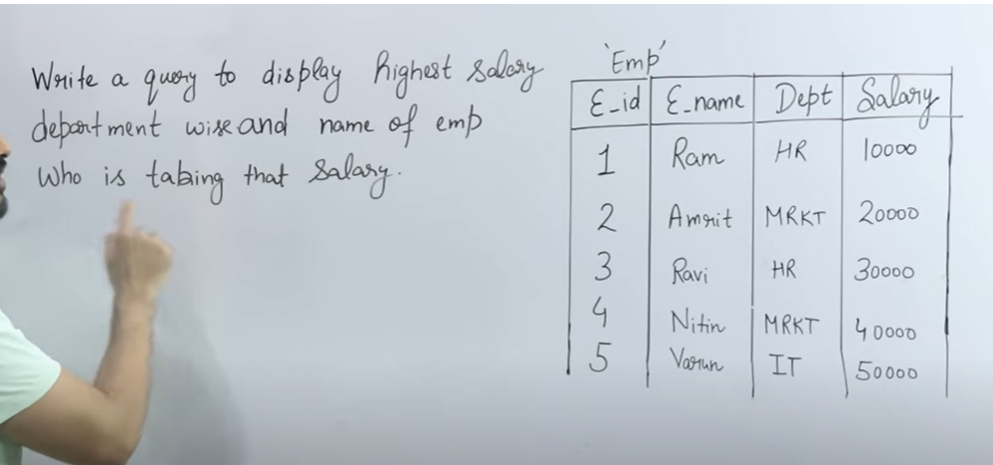

We need to find higest salary in each dept

And also employee who is taking that salary

Select from table groupby dept

Select dept,from tabl groupby dept

Select dept, max(salary) from table group by dept

* Now we need to find those employees

But here we need only salaries

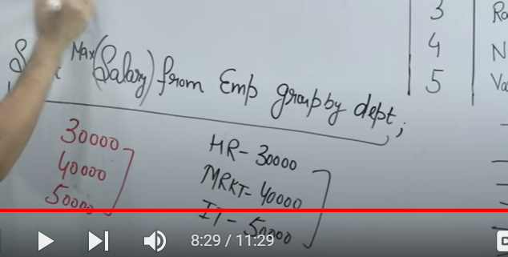

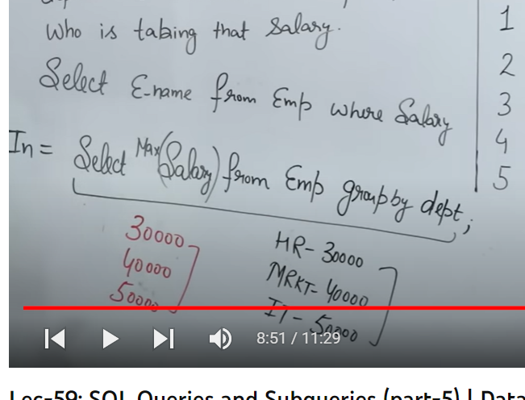

-IN NOT IN in sub quires

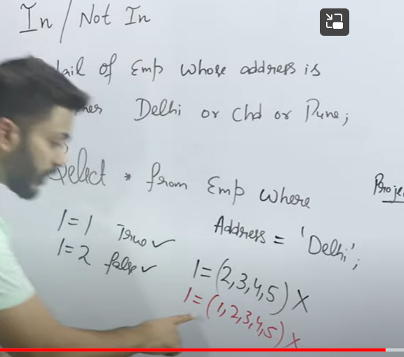

= will not work for more than one value

Or comparing more than one value

We should use in

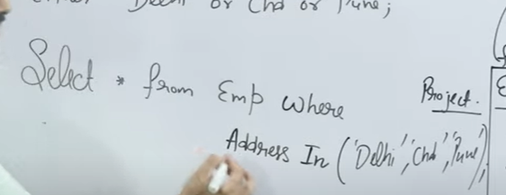

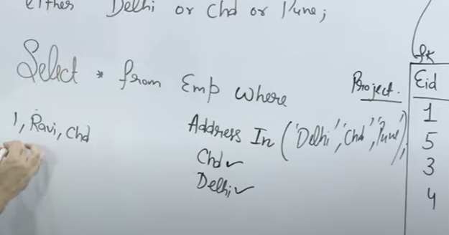

It takes one record check if that’s there in IN list and return that record if condition is true

Correlated sub query:-Synchronized query

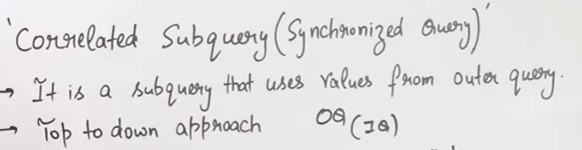

**Inner quey uses outer query**